SEPARATION (MY RESGINATION)
URL : https://drauat.elitehrms.com
User Name : 0066
Password : M@ster
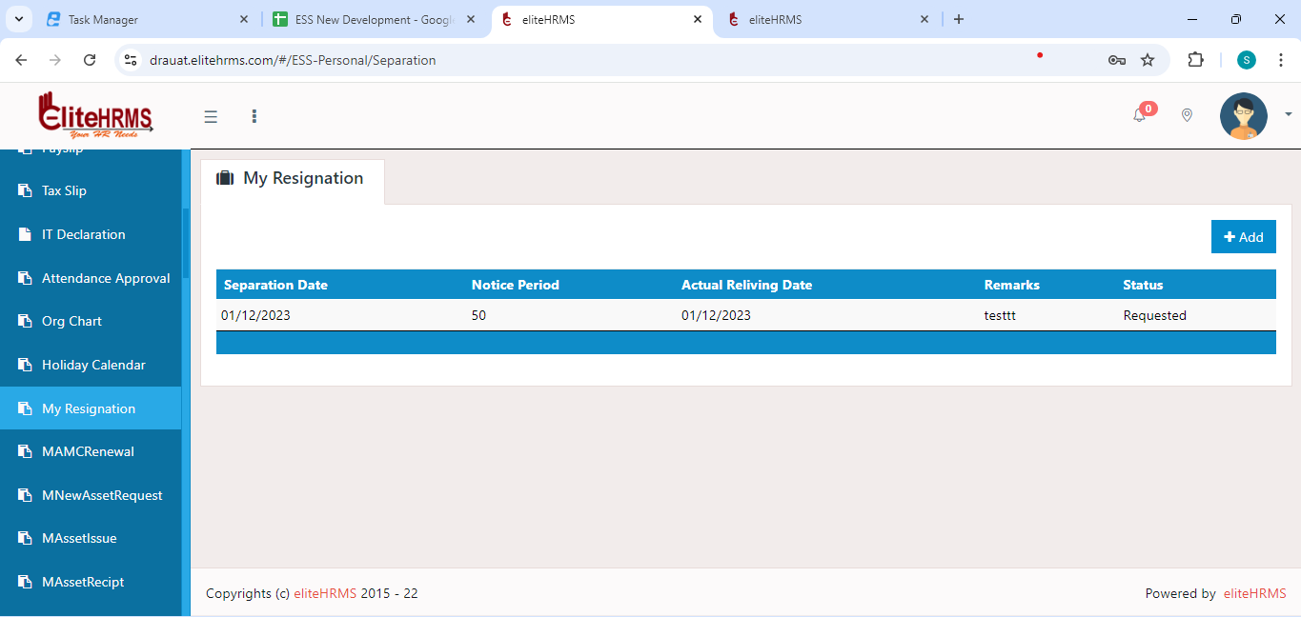
1.first page need to search page.

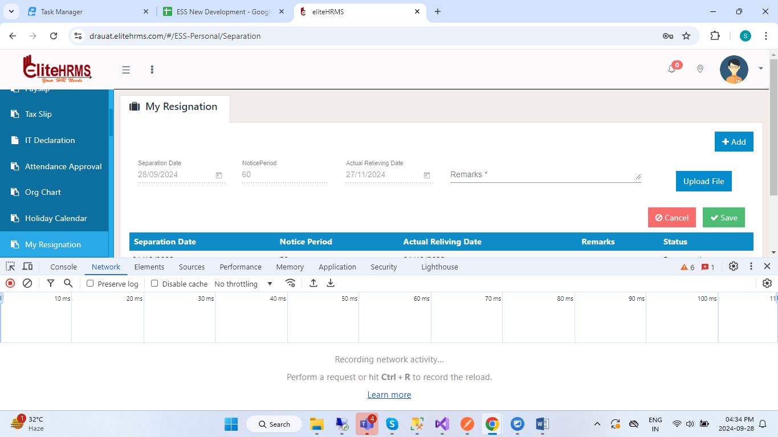
2.then click create button, Separation date set to Current date
3.Noticeperiod, ActualRelivingdate value to use GetNoticeSeparationDetails.
4.Upload file button use web3 based attachment api.

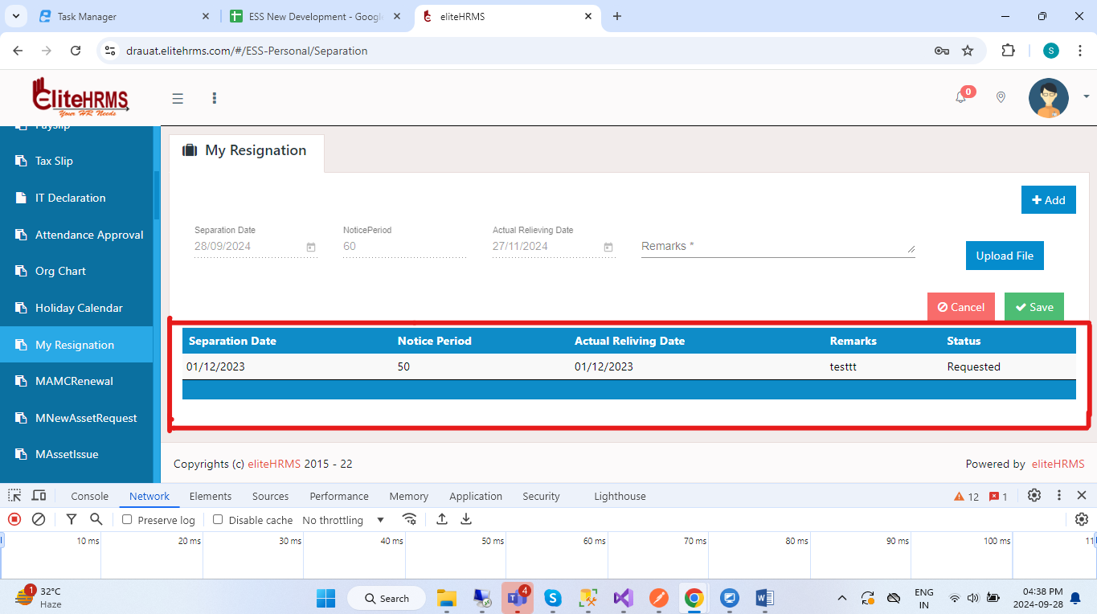
5. To showing grid value call “GetSeparationDetails” api.
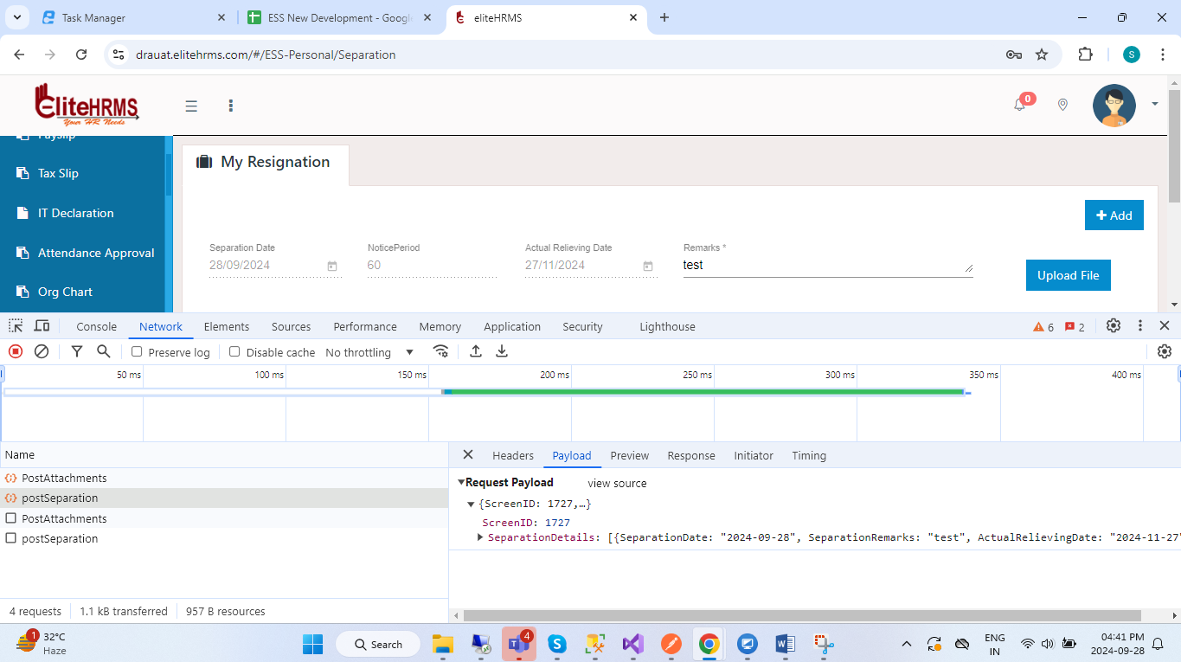
6.All record entered then click save button call “postSeparation” api.

Post api json:
https://localhost:44349/api/Personal/postSeparation
{
"ScreenID": 1727,
"SeparationDetails": [
{
"SeparationDate": "2024-09-27",
"SeparationRemarks": "test",
"ActualRelievingDate": "2024-11-26",
"NoticePeriod": 60,
"SeparationGUID": "763946d4-253c-d39d-2ba8-f961e4c89166"
}
]
}
{
"Response": {
"_status": "Success",
"_code": "111",
"_Source": "postEducationDetails",
"_Description": "Inserted Successfully...",
"_Details": "Workflow screen not added",
"_TransID": null,
"_Timestamp": "20240928164406"
},
"ScreenID": 0,
"NoticePeriod": 0,
"SeparationDetails": [],
"UploadFile": null
}

Employee Notice List api:
https://localhost:44349/api/Personal/GetNoticeSeparationDetails
{
"Response": {
"_status": "Success",
"_code": "111",
"_Source": "GetSeparationDetails",
"_Description": "",
"_Details": "",
"_TransID": null,
"_Timestamp": "20240928163313"
},
"NoticeList": [
{
"NoticePeriod": "0",
"ActualRelivingDate": "2024-09-28"
}
]
}

Get Api json:
https://localhost:44349/api/Personal/GetSeparationDetails
{
"Response": {
"_status": "Success",
"_code": "111",
"_Source": "GetSeparationDetails",
"_Description": "",
"_Details": "",
"_TransID": null,
"_Timestamp": "20240928164520"
},
"ScreenID": 0,
"NoticePeriod": 0,
"SeparationDetails": [
{
"SeparationGUID": "763946d4-253c-d39d-2ba8-f961e4c89166",
"SeparationID": "1",
"Division": "",
"DepartmentName": "Sales",
"SubDepartment": "",
"Grade": "",
"RelevingName": "Draft",
"SeperationName": "Resigned",
"separationDate": null,
"Code": "INOVA-0002",
"Name": "K Subramania Bharathiyar",
"RelievingType": "6736",
"SeparationType": "6696",
"SeparationDate": "27/09/2024",
"NoticePeriod": "0",
"ActualRelievingDate": "27/09/2024",
"SeparationRemarks": "test"
}
],
"UploadFile": null
}

